**Technology extrapolation domains (TEDs) for the conterminous United States**

**Introduction**

A robust spatial framework that delineates regions in which crop production technologies perform similarly can help address current limitations on extrapolation of results from agronomic ﬁeld experiments to larger regions. In principle, the impact of a particular agronomic technology should be predictable and of reasonably similar magnitude within a spatially deﬁned region with similar biophysical attributes. We developed a spatial framework called Technology Extrapolation Domains (TEDs) that delineates regions based on four biophysical attributes that govern rainfed crop yield and its inter-annual variability: (i) annual total growing degree-days (GDD), which, in large part, determines the length of crop growing season, (ii) aridity index (AI), which largely deﬁnes the degree of water limitation in rainfed cropping systems, (iii) annual temperature seasonality (TS), which diﬀerentiates between temperate and tropical climates, and (iv) plant-available water holding capacity in the rootable soil depth (PAWHC), which determines the ability of the soil to supply water to support crop growth during rain-free periods ***(Figure 1)***. A unique combination of these four biophysical attributes is hereafter referred to as a ‘technology extrapolation domain’ (TED). Here we describe the development of the TEDs for the conterminous United States.

***Figure 1****. Technology extrapolation domains (TEDs) in the United States. Each TED corresponds to a unique combination of growing degree-days, aridity index, temperature seasonality, and plant available water holding capacity. Source: Rattalino Edreira et al (2018)*

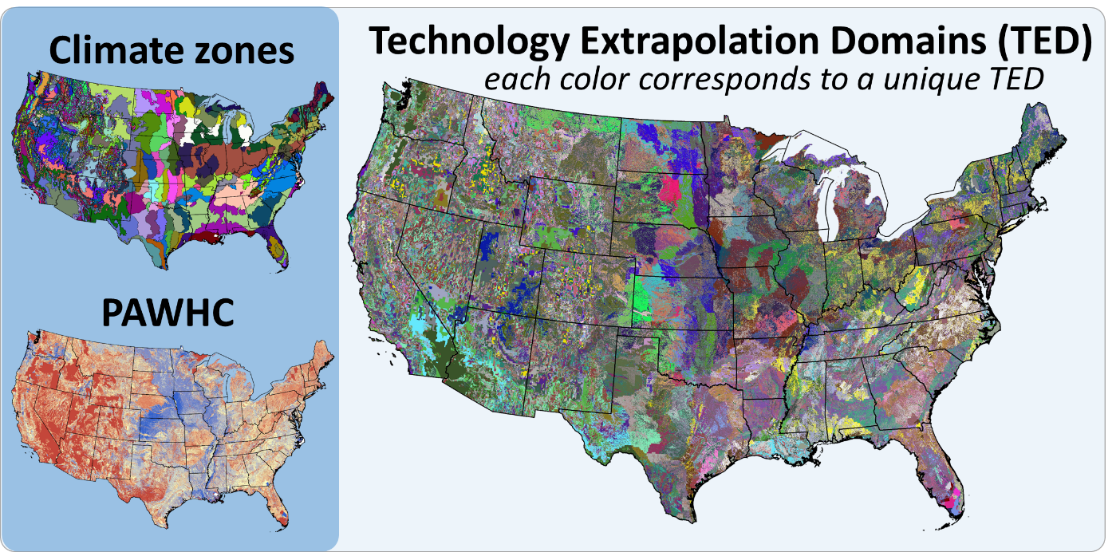

**Data sources and calculations**

Data source and calculation of four biophysical attributes are described below.

1. Growing degree-days

The GDD were calculated as in Licker et al. (2010) with:

$$GDD= \sum{max⁡(0,Ti-Tb)}$$

were *Ti* is the mean monthly temperature (°C) and is *Tb* the base temperature that was set to 0 °C for our calculations. Licker et al. (2010) used mean monthly temperatures for the period 1961-1990 from the CRU CL v.2.0 dataset at 10' grid (http://www.cru.uea.ac.uk/cru/data/hrg/tmc/, New et al., 2002) and downscaled it to a 5' grid (roughly 100 km2 at the equator).

1. Temperature seasonality

A map of temperature seasonality at 5' grid was downloaded from WorldClim (BioClim4) using data for current conditions (~1950-2000) (http://www.worldclim.org/current, Hijmans et al., 2005) Temperature seasonality was calculated as the standard deviation of the (12) mean monthly temperatures × 100. We note that mean monthly temperatures reported in WordClim are in °C × 10.

1. Aridity index

Annual aridity index at 30'' grid were taken from CGIAR-CSI (http://www.cgiar-csi.org/data/global-aridity-and-pet-database, Trabucco et al., 2008; Zomer et al., 2008), which was calculated as:

$$AI= \frac{MAP}{MAE}$$

where *MAP* is the mean annual precipitation (mm × 100) and *MAE* the mean annual potential evapotranspiration (mm × 100). AI was aggregated to a 5' grid, taking the spatial average of the 100 cells at 30 arc second resolution within each 5 arc-minute grid cell. Next, we multiplied the spatially averaged AI by 10000.

1. Plant-available water holding capacity in the rootable soil depth

Data on plant-available soil water holding capacity in the rootable zone was taken from gSSURGO database (Soil Survey Staff, 2016). Data were downloaded at a 30-m resolution and then aggregated to 250 x 250 m pixels. PAWHC (mm) represents the capacity of the soil to store water to support crop growth, which determines the degree to which a soil can buffer against rain-free periods. PAWHC depends on the depth to which roots can grow, as determined by soil physical and chemical properties, and on texture.

**Aggregation of biophysical variables in classes**

Following Van Wart et al. (2013), aridity index and GDD values were aggregated into 10 classes and combined in a grid matrix with 3 classes of temperature seasonality to give a total of 300 classes (referred to as “climate zones”). Some small climate zones were considered irrelevant for technology transfer and removed from the map. Inclusions were removed when (i) they covered an area < 350,000 ha, (ii) the surrounding climate zone was, at least, 5 times larger, and (iii) standard deviation for terrain elevation was <10% (USDA-FSA-APFO, 2016). This rule aims to discard small inclusions attributable to an artefact in the computation of climate zones while keeping small climate zones that portray microclimates caused by changes in temperature and precipitation due to complex topography. PAWHC values were classified into seven 50-mm classes, with 0-50 mm as the lower class and >300 mm as the upper class. The refined climate zones were combined with the PAWHR map to create the TED maps, where each grid is assigned to a TED based upon the combination of the four biophysical variables (GDD, AI, TS, and PAWHC).

A coding system allows identifying the combination of biophysical attributes. Briefly, a unique code is assigned to each of the classes of biophysical variables. Then the code of the four biophysical variables within a given TED grid is added together to determine the code of the TED grid. Large GDD values correspond to warm locations while high TS values are associated to site with large differences in temperature among seasons. In the case of AI, low and high value are associated to dry and wet environments, respectively.

Coding for the biophysical variables is shown below:



Example for a hypothetical TED codes are shown below:



A finer TED framework with higher resolution for the PAWHC layer is available. This framework uses the same range of values for the climatic attributes GDD, AI, and TS, and classifies PAWHC values into thirteen 25-mm classes, with 0-25 mm as the lower class and >300 mm as the upper class.

Coding for the biophysical variables of the finer TED framework is shown below:



**TED evaluation**

Although the TED framework can be applied worldwide, evaluation of the TEDs required detailed and spatially explicit data of weather, soil, crop management and yields. The TED spatial framework was evaluated on its capacity to account for variation in crop performance and management practices across spatial and temporal dimensions using soybean and maize in the US Corn Belt as case studies (Rattalino Edreira et al., 2018). In that study, the TED framework was able to distinguish regions with different yield level, yield stability, and management practices for the two crops (maize and soybean), across two spatial scales (county- and ﬁeld-level), and two dimensions (temporal and spatial) over a large geographic region with diversity in climate and soil that account for about one-third of global maize and soybean production. On a separate study, Mourtzinis et al. (2020) compared the performance of different stratification methods, including the TEDs, to group farmer fields according to their biophysical background. Despite its simplicity, the TEDs exhibited similar performance to other more data-intensive approaches relying on a larger number of parameters.

**TED application**

The TED framework presented here can help (i) optimize the number of environments covered by a ﬁeld trial to maximize the crop area coverage or, alternatively, to reduce the number of sites without sacriﬁcing crop area coverage, (ii) select speciﬁc environments for testing a technology where it is most likely to have the greatest impact based on biophysical attributes of the selected TEDs, (iii) up-scale results from experiments or field trials to larger geographic areas, and (iv) identify geographic areas where a given technology is expected to have a similar impact. Examples showing applications of the TED framework can be found elsewhere (Andrade et al., 2019; Mourtzinis et al., 2018; Rattalino Edreira et al., 2017).

**References**

Andrade, J.F. et al., 2019. A spatial framework for ex-ante impact assessment of agricultural technologies. Global Food Security, 20: 72-81.

Hijmans, R.J., Cameron, S.E., Parra, J.L., Jones, P.G. and Jarvis, A., 2005. Very high resolution interpolated climate surfaces for global land areas. International Journal of Climatology, 25(15): 1965-1978.

Licker, R. et al., 2010. Mind the gap: how do climate and agricultural management explain the ‘yield gap’ of croplands around the world? Global Ecology and Biogeography, 19(6): 769-782.

Mourtzinis, S. et al., 2020. Assessing approaches for stratifying producer fields based on biophysical attributes for regional yield-gap analysis. Field Crops Research, 245: 107825.

Mourtzinis, S. et al., 2018. Sifting and winnowing: Analysis of farmer field data for soybean in the US North-Central region. Field Crops Research, 221: 130-141.

New, M., Lister, D., Hulme, M. and Makin, I., 2002. A high-resolution data set of surface climate over global land areas. Climate Research, 21: 1.

Rattalino Edreira, J.I. et al., 2018. Beyond the plot: Technology extrapolation domains for scaling out agronomic science. Environmental Research Letters, 13(5): 054027.

Rattalino Edreira, J.I. et al., 2017. Assessing causes of yield gaps in agricultural areas with diversity in climate and soils. Agricultural and Forest Meteorology, 247: 170-180.

Soil Survey Staff, 2016. National Value Added Look Up (valu) table database for the Gridded Soil Survey Geographic (gSSURGO) Database for the United States of America and the Territories, Commonwealths, and Island Nations served by the USDA-NRCS. United States Department of Agriculture, Natural Resources Conservation Service.

Trabucco, A., Zomer, R., Bossio, D., van Straaten, O. and Verchot, L., 2008. Climate change mitigation through afforestation/reforestation: A global analysis of hydrologic impacts with four case studies. Agriculture Ecosystems & Environment.

USDA-FSA-APFO, 2016. The Geospatial Data Gateway. National Elevation Dataset 10 Meter. [www.datagateway.nrcs.usda.gov](http://www.datagateway.nrcs.usda.gov).

Zomer, R.J., Trabucco, A., Bossio, D.A. and Verchot, L.V., 2008. Climate change mitigation: a spatial analysis of global land suitability for clean development mechanism afforestation and reforestation. Agriculture Ecosystems & Environment, 126: 67-80.